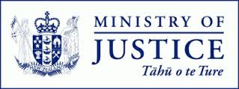
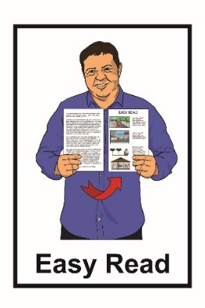

A new adoption system for
Aotearoa New Zealand
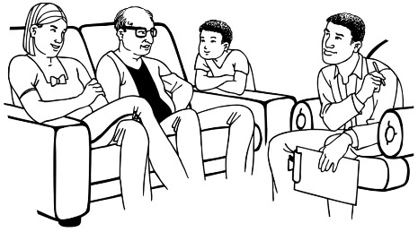

Part 2:
Have your say about adoption laws

July 2022
What you will find in here

Page number:
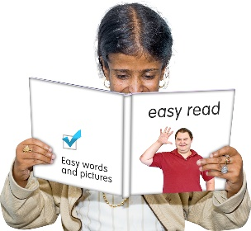

What is this document about?..................3

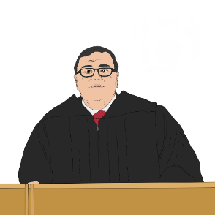
Who makes the decisions
about adoption? 7

How are decisions about
adoption made? 11

What is the legal effect of adoption? 17
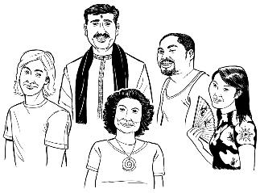

Contact between adopted children and birth parents 25

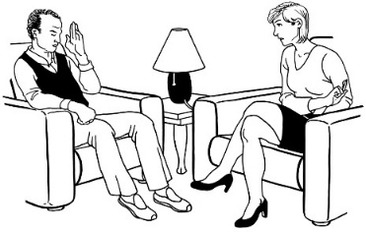
Page number:

What support can people get? 28

Information about the adoption 29
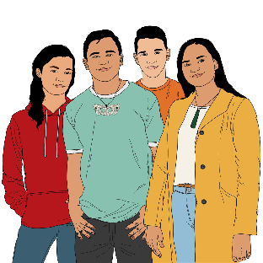

What if things go wrong? 34

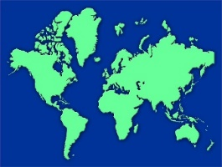
Adoptions with other countries 38

Tell us what you think 41

Where to find more information 44

What is this document about?

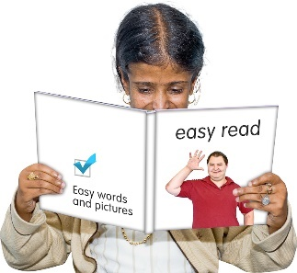
This document is about changes to adoption laws in Aotearoa New Zealand.

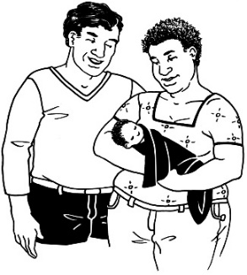
The Ministry of Justice is looking at making new adoption laws for Aotearoa New Zealand.

They want to know what people think about these changes.
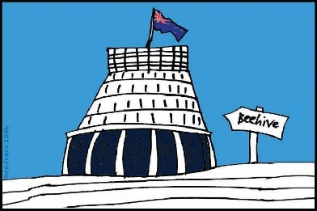
The Government will use what people say to decide the best ways to change adoption laws.

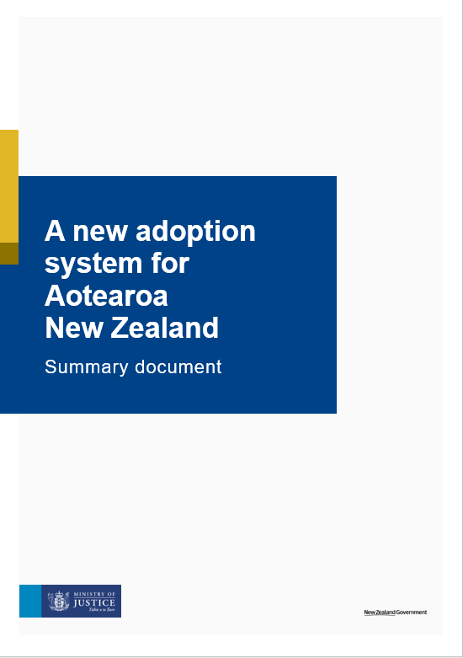
There are many reasons to look at changing the adoption laws.

The Ministry of Justice has written a document called:

A new adoption system for Aotearoa New Zealand: Summary document.

You can find this report on the Ministry of Justice website:

https://justice.govt.nz/adoption-law-reform/

In this Easy Read document we means the Ministry of Justice.

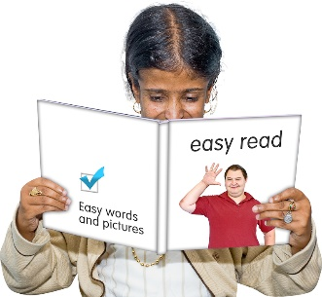
This is an Easy Read translation of the summary document.

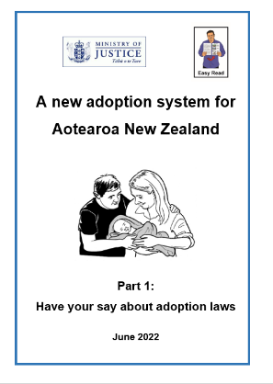
This Easy Read translation looks at some of the main things in the summary document.

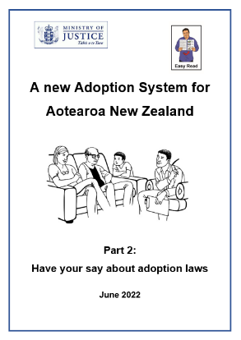
The Easy Read translation is in 2 parts.

This document is Part 2.

You can find Part 1 on the Ministry of Justice website:

https://justice.govt.nz/adoption-law-reform/

The Easy Read translation is a long document.

If you want to you can:
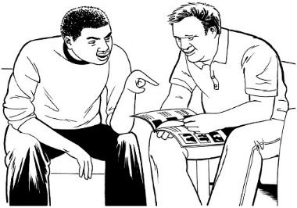
- ask someone you know to read it with you
- read a little bit at a time.

Who makes the decisions about adoption?

Making decisions
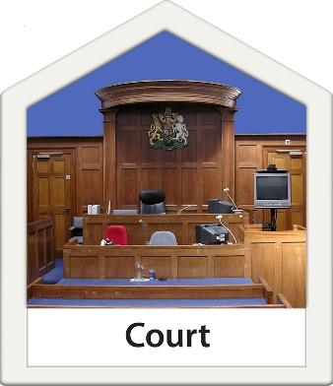

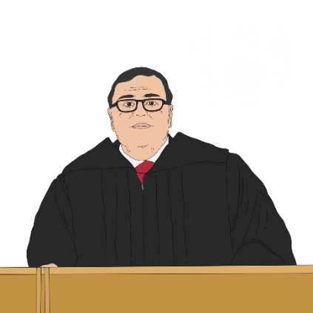
The Family Court makes decisions about adoptions that happen in Aotearoa New Zealand.

We think the Family Court should keep making those decisions.

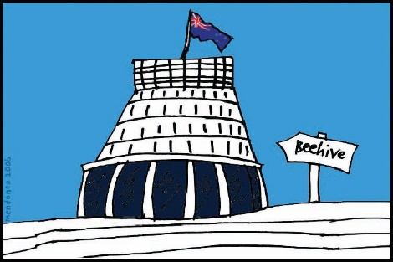
We think other parts of adoption like assessments are best done by government agencies.

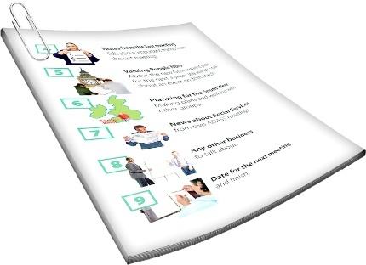
Assessments are when someone:
- finds out information
- writes down what things are like.
Assessments are used as part of deciding if people are a good fit for adopting children.

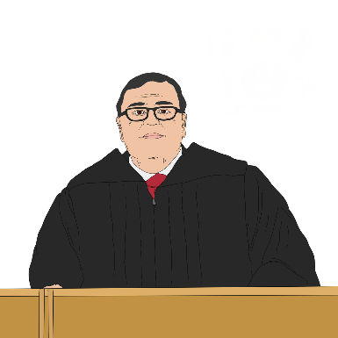
We want you to know if you think that:
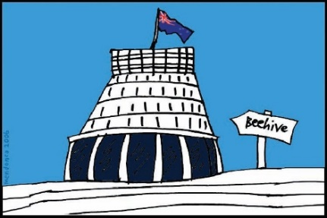
- the Family Court should keep making decisions
- assessments should be done by government agencies.

Support from Oranga Tamariki

We think all people who want to adopt children should have to work with Oranga Tamariki before going to court.
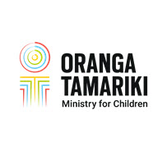

Oranga Tamariki is the part of the government responsible for children.

This means Oranga Tamariki can:
- check if the people wanting to adopt will make good adoptive parents
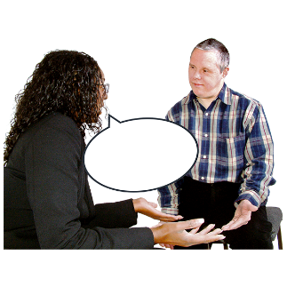
- check what is best for the child early on
- support birth parents if anyone is pushing them to agree to have their child adopted.
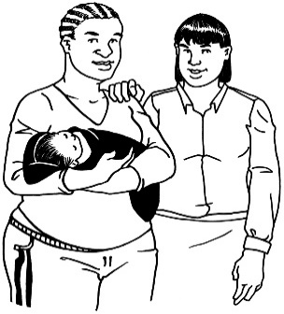
This also means Oranga Tamariki can give the people who want to adopt a child:
- support
- education.

We want to know if you think people should have to work with Oranga Tamariki before they can adopt a child.
How are decisions about adoption made?

Suitability of people who want to adopt

Being suitable to adopt means someone would be able to look after a child well.

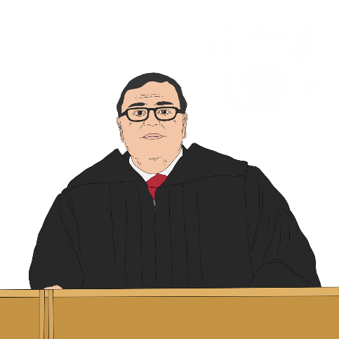
We think a judge should know people are suitable to adopt before agreeing to an adoption.

We do not think there should be strict rules on how to decide if people are suitable.

We think the judge should decide by looking at information.

We want to know:
- if you think a judge should decide if people are suitable to adopt
- what information the judge should use to make a decision.

Social worker report

A social worker writes a report that is part of the information the court uses to decide if the adoption should happen.

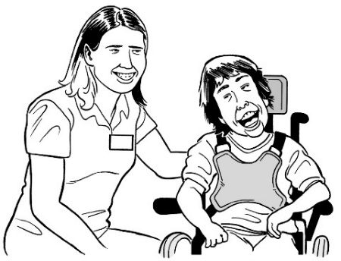
We think the law should say some of the things that need to be in the report like:

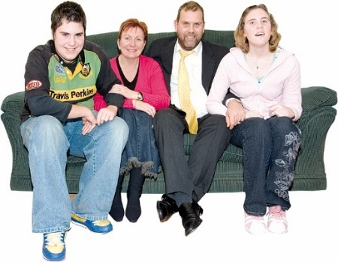
- how the child was part of thinking about the adoption
- anything the child said they wanted to happen
- the suitability of the adoptive parents
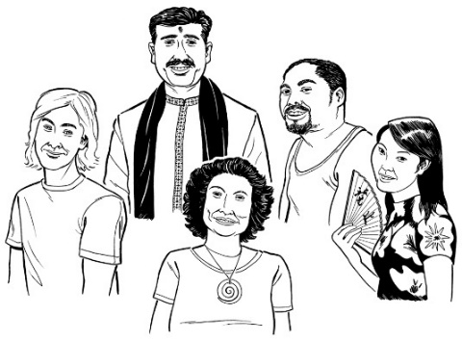
- what the whānau / family of the child think
- information about the culture of the child.
We want to know if you think the law should say some of the things that must be included in the social worker report.

Getting other information

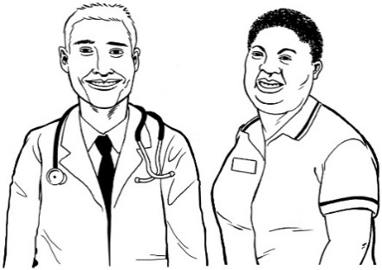
The court may want to order other reports like reports from doctors.

We think the court should be able to ask for the reports they think they need to make a decision about the adoption.

We want to know what you think about the court being able to order extra reports.

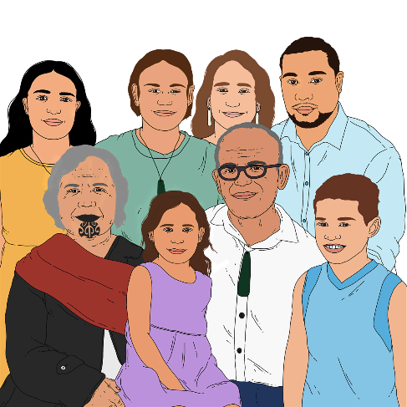
Other care options

There are other types of care such as guardianship orders where the child can stay more connected to their birth family / whānau.

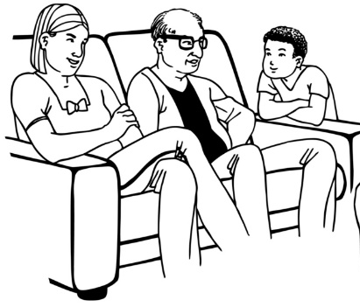
A guardianship order means someone is able to make legal decisions about the care of the child but is not the legal parent of the child.

We think the judge should know that other types of care have been thought about before they agree to an adoption.

We want to know if you think that judges should know other types of care have been looked at before agreeing to an adoption.
What is the legal effect of adoption?

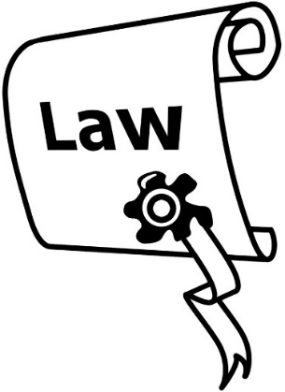
The legal effect of adoption is about how it changes how the law sees:

- people
- their relationships with each other.

Final adoption orders

We think judges should always make a final adoption order unless there is a good reason to make an interim order.

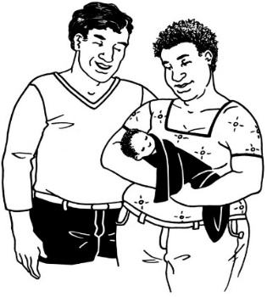
A final adoption order means the adoptive parents become the parents of the child.

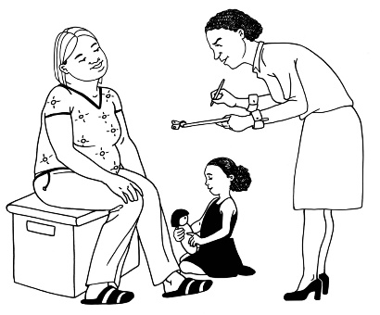
An interim order is a decision that only lasts for a short time.

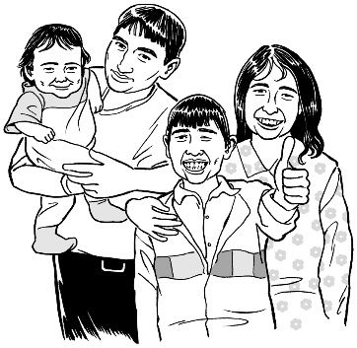
A final adoption order would make the relationship certain for the child and adoptive parents.

We want to know if you think there are any times when interim orders should be used.

Legal effect

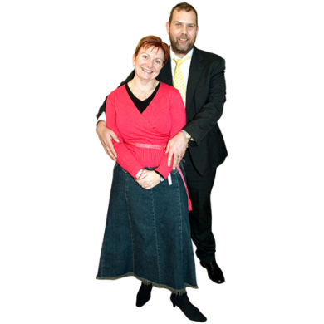
We think an adopted person should both:
- be able to keep a legal connection to their birth parents
- have a new legal connection to their adoptive parents.

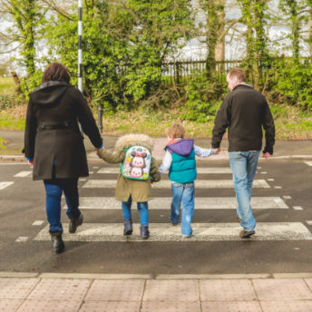
We think adoptive parents should:
- have guardianship responsibilities for the child
- have to pay the costs of raising a child like paying for food for them.

Guardianship responsibilities means things like:
- looking after the child
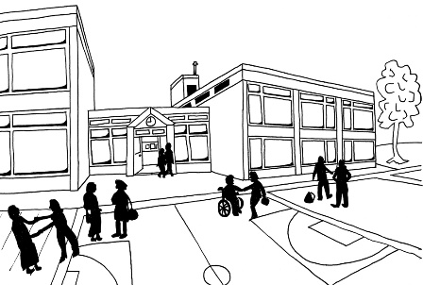
- deciding things like:
  - where the child lives
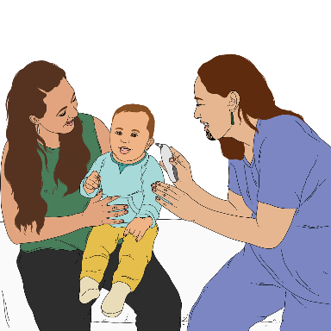
  - where the child goes to school
  - what medical treatment they get.

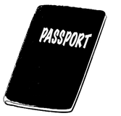
Adopted people should be able to get citizenship from both sets of parents.

Citizenship is when you can get a passport from a country.

Inheriting property
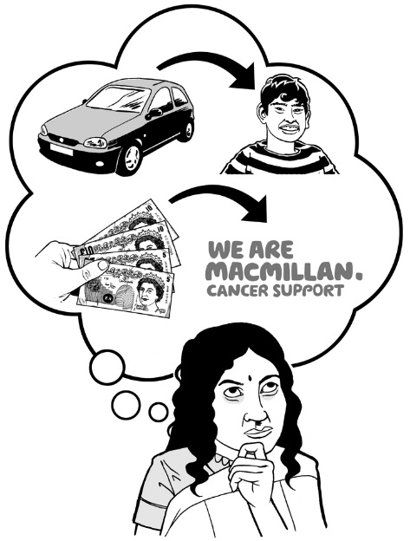
Inherit is when you get things like a house or money when a family / whānau member dies.

At the moment adopted people can only inherit from their birth parents if their birth parents say so in their will.
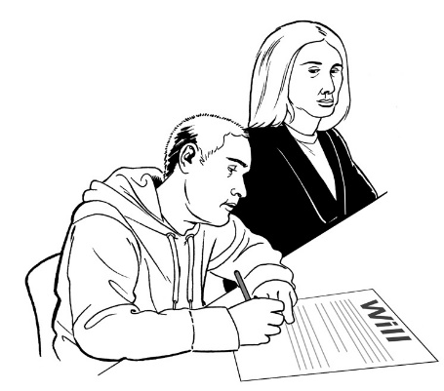
A will is something you write to say what you want to happen to your things when you die.

We are interested in what you think the inheritance rules should be for adopted people.

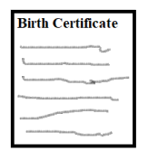
Birth certificates for adopted people

Every person born in Aotearoa New Zealand has information about their birth recorded on a birth certificate.

A birth certificate is a document that has information about the:

- date the person was born
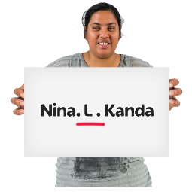
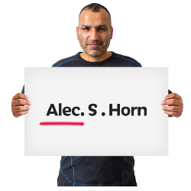
- place where they were born

- names of the birth parents.

We suggest that adopted people should have 2 birth certificates.

1 birth certificate will say only the names of their adoptive parents.

The other certificate will say both:
- the names of their birth parents
- the names of their adoptive parents.

We want to hear if you think adopted people should be able to get 2 birth certificates.

Changing the names of adopted children
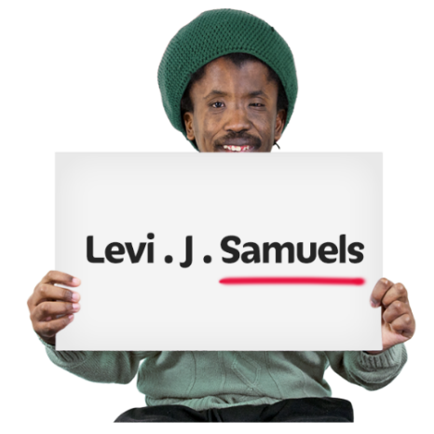

We think a judge should decide if the surname / last name of the person is changed when they are adopted.

We are also thinking about times the court could change the first name of a child when they are adopted.

We want to know:
- if you think the name of an adopted child should be able to be changed
- when name changes should be allowed.

Contact between adopted children
and birth parents

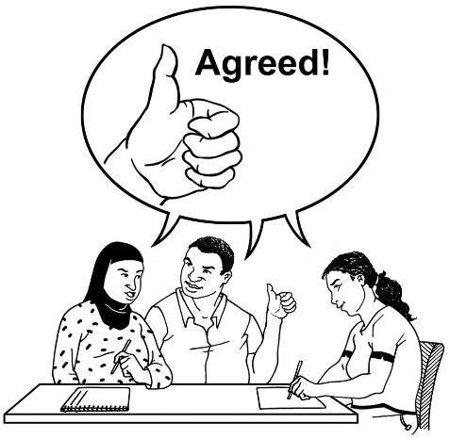
Contact after adoption

We suggest families should agree on what contact the children have with their birth families.

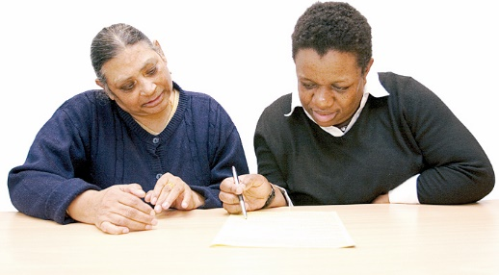
This agreement can be:
- written down
- changed over time.

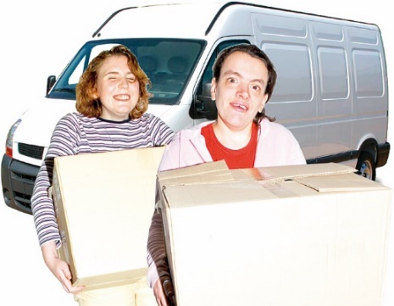
We also suggest adoptive parents should have to talk to the birth parents about how to keep in contact if they move to another place.

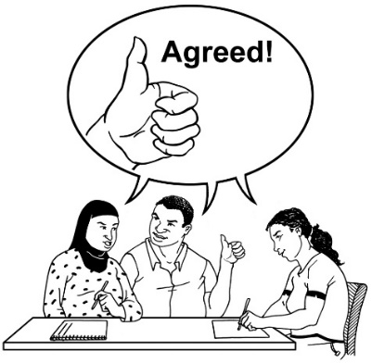
We want to know if you think:
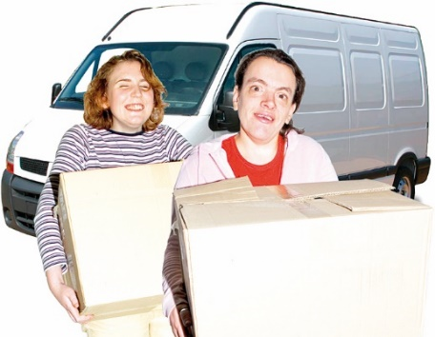
- families should have to make a contact agreement before adoption
- adoptive parents should have to talk to birth parents if they move away.

Culture plans

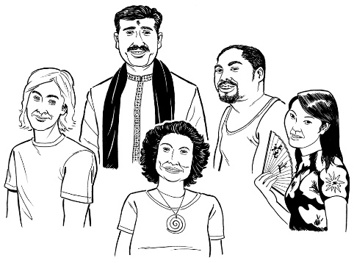
We are also thinking about if there should be culture plans if the child comes from a different culture to the adoptive parents.

A culture plan would:
- say the child has a right to their culture
- say how the adoptive parents will make sure the child stays in touch with their culture.

We want to know what you think about culture plans.

What support can people get?
We think it is important everyone can get the support they need.

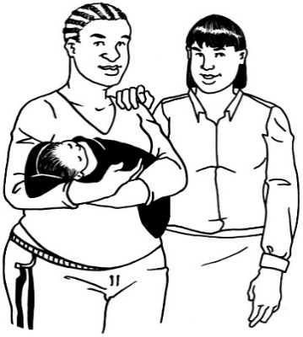
We want to hear what you think about:
- what kinds of support should be available
- who should be able to get support
- when people should be able to get it.

Information about the adoption

Information for adopted people

We think the law should make it so adopted people can get information about their adoption:
- faster
- more easily.

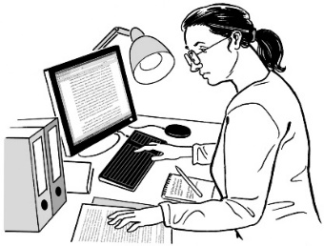
Information might be things like:
- birth certificates
- Oranga Tamariki information
- court information.

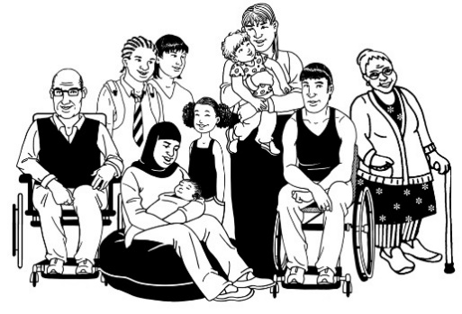
We suggest adopted people should be able to get information about their adoption at any age.

We want to know if you think getting information for adopted people should be:
- faster
- easier
- something they can do at any age.

Other people seeing birth records

In most cases anyone can see birth records.

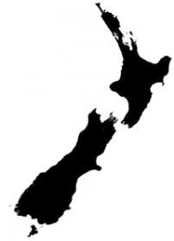
Birth records are information about people like:
- when they were born
- where they were born
- what their name is
- who their parents are.

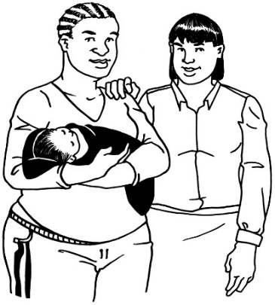
When someone is adopted people looking at their birth records cannot see all the information.

They can usually:
- only see the adoptive parents not their birth parents
- not see that the person were adopted.

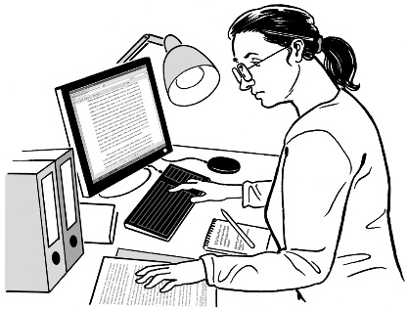
We think these people should be able to see all the information on the birth record of an adopted person:

- the adopted person
- their birth parents.

We want to know who else you think should be able to see all that information.
Vetoes

A veto is a way of stopping something.

At the moment some people have vetoes which stop people seeing the full birth record.

Often the people with the veto are birth parents who use it to stop the adopted person finding out who they are.

We want to know if you think vetoes should still be allowed.

What if things go wrong?

Varying an adoption order

Varying means to change.

We are thinking about if the law needs to say when the court can vary an adoption order.

We want to know when you think a judge should be able to change an adoption order.

Discharging an adoption order

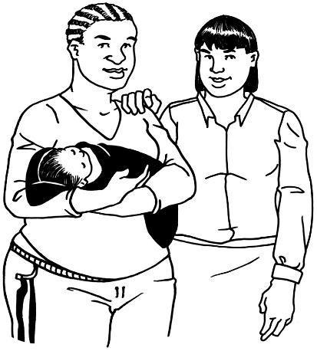
When an adoption order is discharged it means:
- the child is no longer adopted
- the birth parents are the legal parents again.
We have been thinking about what the rules should be for when an adoption order can be discharged.

We think the people who can ask for an adoption to be discharged should be:
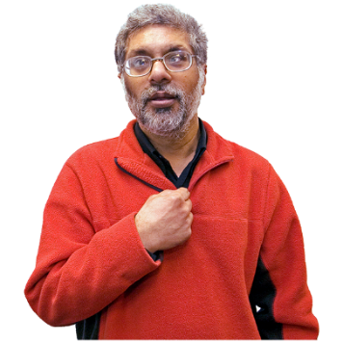
- the birth or adoptive parents if the adopted person is a child
- the adopted person if they are an adult.
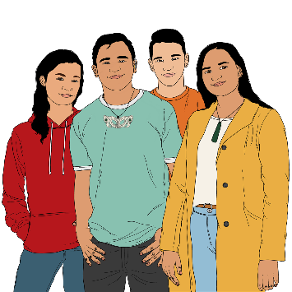

We are thinking about if 16 and 17 year olds should also be able to ask for the adoption to be discharged.

We do not think birth or adoptive parents should have to agree to the adoption being discharged.

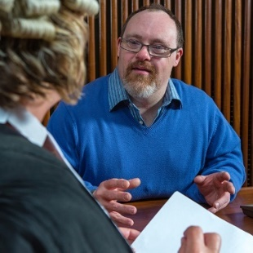
We do think they should be able to tell the court what they think if they want.

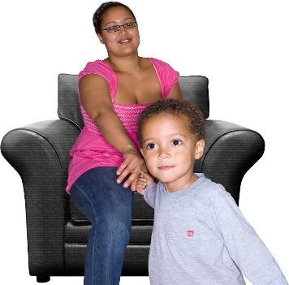
If the adopted person is a child the court will need to think about who will care for the child.

We want to know what you think about:
- who can apply to discharge an adoption order
- when an adoption order should be able to be discharged
- if the birth or adoptive parents should have to agree to an order for an adult being discharged
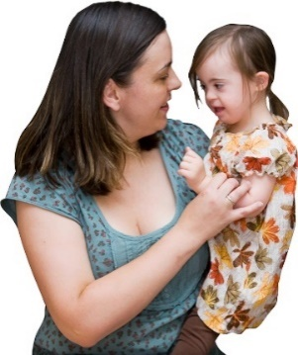
- if the court should have to think about who will take care of the child.

Adoptions with other countries

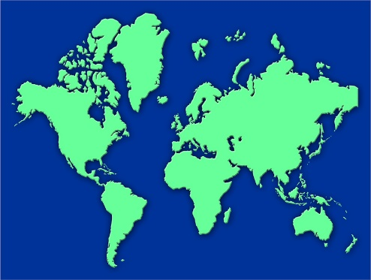
We think it is important to have good rules about adoption of children from other countries.

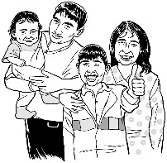
We think the law could look at these adoptions in two groups:
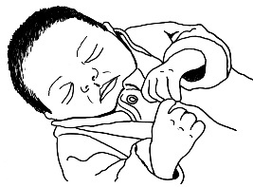
- overseas adoptions are where a family who live in another country adopt a child and then move to New Zealand
- intercountry adoptions are where people in New Zealand adopt a child from another country.

We do think there should be rules:
- for when New Zealand recognises an overseas adoption
- to make sure intercountry adoptions are best for the child.

We do not think overseas adoptions should have to go through the court in New Zealand.

We want to hear what rules you think there should be for:
- overseas adoptions
- intercountry adoptions.

Hague Convention adoptions

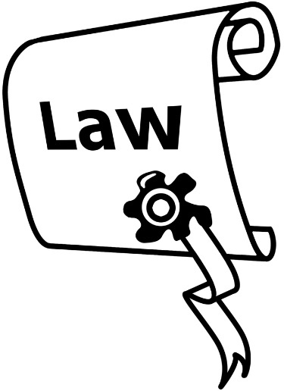
The Hague Convention is an international law about children being adopted between different countries.

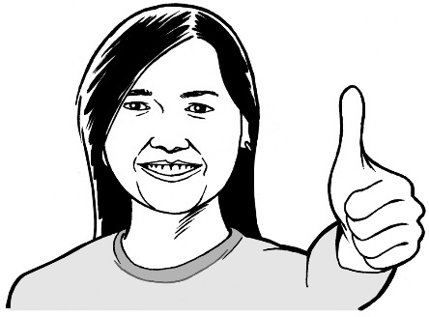
An international law is a set of rules that many countries agree should apply

We think the Hague Convention is a good way of doing things.

We want to hear if you think New Zealand should keep having adoptions happen under the Hague Convention.

Tell us what you think

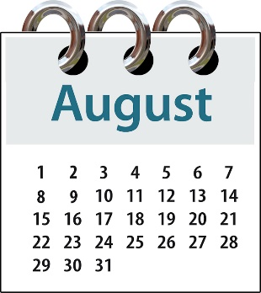
You will need to tell us what you think by:

- Sunday 7 August 2022

- 5.00 pm

You can fill out the form on our website at:
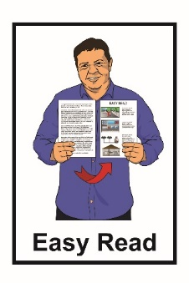
https://consultations.justice.govt.
nz/

The form is not in Easy Read.
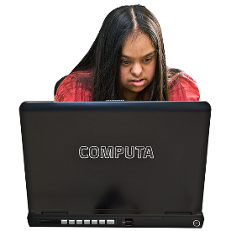

You can ask someone you know to support you with filling in the form.

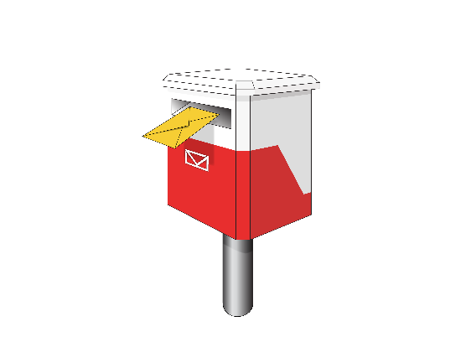
You can send us a letter at:

Adoption Law Reform

SX10088

Wellington 6011

You can email us at:

adoptionlaw@justice.govt.nz
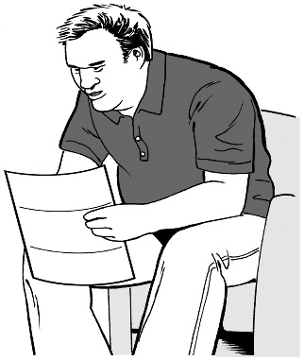
It is important to know that any information you send us could be asked for by someone else under the Official Information Act 1982.

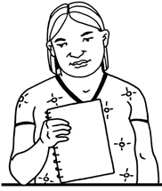
The Official Information Act 1982 is a law that lets anyone in New Zealand ask the government for information they have.

The information asked for must be given unless there is a good reason to not give it out.

The privacy policy of the Ministry of Justice can be found at:
https://consultations.justice.govt.nz/privacy_policy/

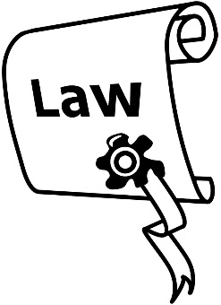
A privacy policy is a document telling you what an organisation does with any information you give them.
Where to find more information

You can find more information about this adoption law work on the Ministry of Justice website:

https://consultations.justice.govt.nz/policy/adoption-law-reform/

You can also contact us to ask for more information by:

- email:

adoptionlaw@justice.govt.nz

- phone:

04 918 8800

This information has been written by Ministry of Justice.
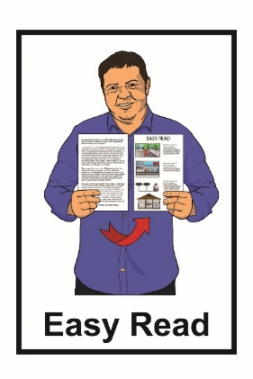
It has been translated into Easy Read by the Make It Easy service of People First New Zealand Inc. Ngā Tāngata Tuatahi.

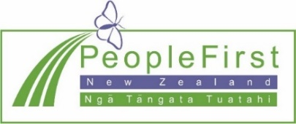
The ideas in this document are not the ideas of People First New Zealand Inc. Ngā Tāngata Tuatahi.

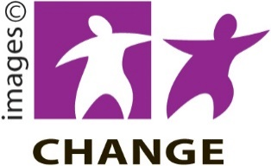
Make It Easy uses images from:

- Changepeople.org

- Photosymbols.com

- SGC Image Works

- Huriana Kopeke-Te Aho.
All images used in this Easy Read document are subject to copyright rules and cannot be used without permission.

